
Year 8 Mathematics
Semester 2 Exam

Resources Allowed: One A4 page of notes (2-sided) and calculator

Time: 60 mins Name: _______________________________ / 60 marks

Full working out must be shown to get full marks. Attempt all the questions.

Part A 21 marks
For each word below, write the letter of the matching definition.
- [3 marks]
A: A possible result.
B: All possible results.
C: An activity that involves chance.
D: Doing the activity.
E: A particular result.
F: Not a particular result.
______ Probability Experiment
______ Outcome
______ Sample Space
______ Event
______ Complement
______ Trial

- For each of the following equations find the value of $x$. [7 marks]

- $x+7=12$ | - $2x+3=17$
- $3\left(x+4\right)=18$ | - $2x+6=4(x-2)$

- The letters of the word STATISTICS are written on 10 cards. The cards are placed in a hat and one card is chosen at random. [4 marks]

a) State the sample space b) Find the probability of choosing the letter T

c) Find the probability of choosing a vowel d) What is the probability that the letter chosen will be in the word STATS?

4. Fill in the table and then plot as a linear graph [3 marks]

x | -2 | -1 | 0 | 1 | 2
y | -2 |  | 4 | 7

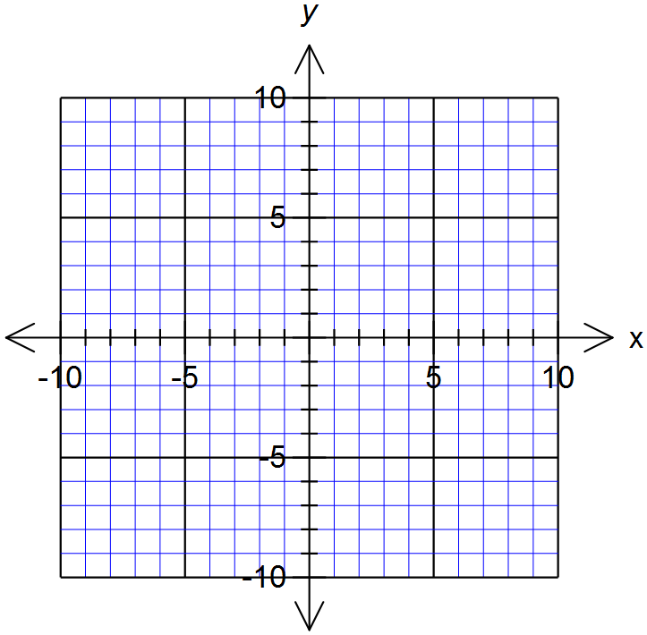

- [2 marks]
A taxi departs at 18:32 from Baldivis and arrives at 20:13 at Armadale. How long did the taxi take for the trip?

- [2 marks]
Ryles in Broome is expecting a phone call from Ella in Sydney. Broome is 3 hours behind Sydney time.

- If Ryles calls at 8:45am, what time is it for Ella?

- If Ella calls at 1:30pm, what time is it for Ryles?

Part B 20 marks

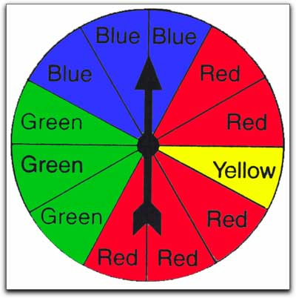
- [4 marks] The following fair spinners are spun. Write the probability, as a fraction, decimal and percentage, of landing on red. What is the probability, as a decimal, of NOT landing on red?
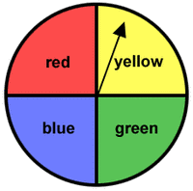
(a) (b)

Fraction: _______________ Fraction: _______________

Decimal: _______________ Decimal: _______________

Percentage: ______________ Percentage: _______________

Pr (R’): _______________ Pr (R’): _______________

- [6 marks]
Consider the following set of data
53, 37, 53, 42, 10, 49, 42, 53, 45, 47

- Calculate;
- Mean | - Median
- Mode | - Range

- Which score in the set of data is an outlier?

- If the outlier is removed, which of the above measures will it affect the most? (Mean, Median, Mode or Range)

- [6 marks] The two-way table below shows the results of a poll conducted of a group of students who own mobile phones to see who pays their own bills.

 | Boys | Girls | Total
Pay own bill | 7 |  | 23
Do not pay own bill |  | 4
Total | 12 | 20

- Complete the above two-way table
- How many people participated in this poll?

- How many of the students surveyed did not pay their own bill?

- Find the probability that a randomly selected student:
- Is a girl who pays her own bill

- Does not pay their own bill

- [4 marks] The following Venn Diagram shows the number of people who like juice and/or soft drinks
Soft drink
Juice

14
10
2

4

- What is the total number of people who like juice?

- What is the number of people who only like soft drink?

c) What is the probability:
i. That a randomly selected person likes neither juice nor soft drink?

ii. That a randomly selected person likes either juice or soft drink or both?

Part C 19 marks


x | -1 | 0 | 1 | 2 | 3
y |  | 1
11. [4 marks] Use the rule y = 3x + 1 to fill in the table below and then graph it

- [6 marks] Find the gradient and y-intercepts for these lines
A

- Gradient = ___________

Y-intercept = _________

Rule: y = ____x + _____

- Gradient = ___________

Y-intercept = _________

Rule: y =______________
B

- [9 marks] A survey is conducted of 50 people, asking who likes coffee and who likes tea. It was found that 20 people liked both, 35 people liked coffee, and 30 people liked tea.

- Represent this using a Venn diagram. (3)

- How many people liked neither tea nor coffee? (1)

- What is the probability of people liking coffee AND tea? (1)

- What is the probability of people liking coffee OR tea? (1)

- Present the survey findings in a two-way table. (3)

End of Test

